Accufy update instructions from v1.5 – v1.6

**Step 1**: Backup ! you must backup your all files & database before update.

**Step 2**: Download the latest Accufy_1.6 script file and extract it on your pc. Open **updates > update_v1.5_v1.6 > “uploads”** folder there you will see **2 zip files** in this folder and you need to upload those files in your server please follow the below directions carefully.

* **application.zip** > upload path: Goto your **project root folder > application** > upload this zip file and extract it inside this folder.
* **assets.zip** > upload path: Goto your **project root folder > assets** > upload this zip file and extract it inside this folder.

**Step 3**: Upload **“updates”** folder in your project root folder

**Step 4** Open a browser and write url like this: [www.yourdomain.com/update](http://www.yourdomain.com/update)s/update_v1.5_v1.6 you will see a page like below here enter your item purchase code for update this script.

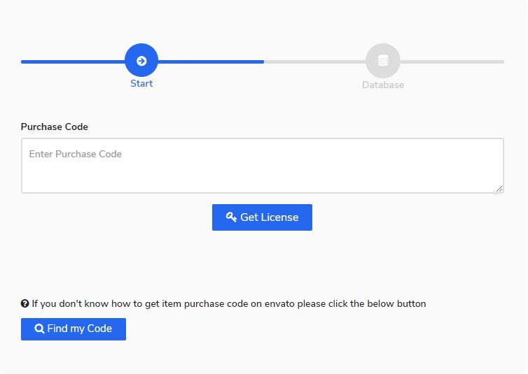

**Step 5**: Here provide your current database credentials and wait few seconds for update your scripts.

